Name:_______________________

**Year 10 Physics Mid Topic Test**

**Formula you may need /57**

[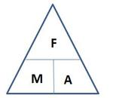](http://www.google.com.au/url?sa=i&rct=j&q=force+mass+acceleration+triangle&source=images&cd=&cad=rja&docid=O6V53PkQA165NM&tbnid=vhNrW-efYEJTlM:&ved=0CAUQjRw&url=http://jdevlin.pottsgrove.wikispaces.net/Physics+Tasks+2012&ei=z6IRUqS2NYyXkgXUoIDwCg&psig=AFQjCNGaoVG_TT9V-bDQMdMZk8qwyYJa6Q&ust=1376973888721903)[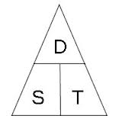](http://www.google.com.au/url?sa=i&rct=j&q=speed%20distance%20time%20triangle&source=images&cd=&cad=rja&docid=l-Td1q_Q0MI0IM&tbnid=cC1NHwB6_ZXB3M:&ved=0CAUQjRw&url=http://www.skoool.co.za/studynotes/maths/id270.htm&ei=haIRUr72K8GHkQX8qoHACw&psig=AFQjCNFf-ofXYSPuXljl_uBwHvbcdC6D5A&ust=1376973815450016)

[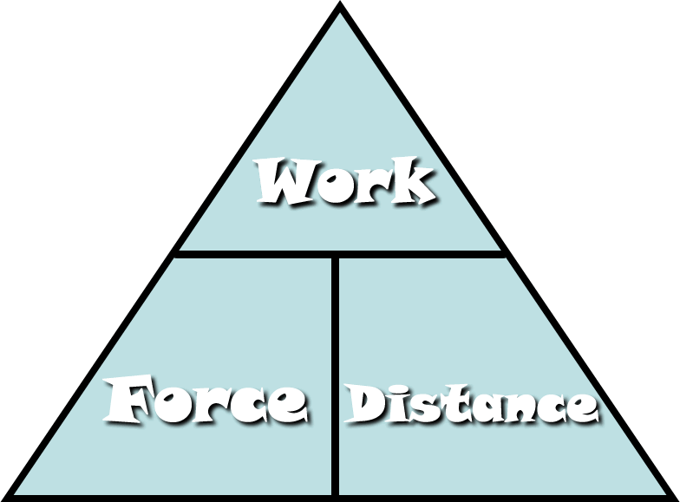](http://www.google.com.au/url?sa=i&rct=j&q=work+force+distance+triangle&source=images&cd=&cad=rja&docid=Fi7mPF8FJi6IOM&tbnid=aV4S5kcpYVNcwM:&ved=0CAUQjRw&url=http://fhm.fhsd.k12.mo.us/jhughes/Hughes/Units/Work&MachinesContent.htm&ei=0aMRUtjOGYyXkgXUoIDwCg&psig=AFQjCNG-nrT1bFGRuWdPLe1VAUwfrjBuYQ&ust=1376974154992588)

[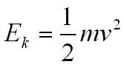](http://www.google.com.au/url?sa=i&rct=j&q=kinetic+energy+formula&source=images&cd=&cad=rja&docid=BZzVErZRq5TMSM&tbnid=KgZmomeJCTMjHM:&ved=0CAUQjRw&url=http://physicsnet.co.uk/a-level-physics-as-a2/mechanics/conservation-of-energy/&ei=UaQRUtzjCsi9kQXBxoGIDQ&psig=AFQjCNH3mfN8ppal1Ay4KsML7bw7tdoQKA&ust=1376974264173183)[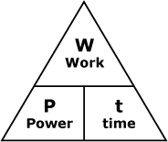](http://www.google.com.au/url?sa=i&rct=j&q=power+woek+time+triangle&source=images&cd=&cad=rja&docid=smEqr3_xk2x1UM&tbnid=FClwhBw-QCE5sM:&ved=0CAUQjRw&url=http://courses.learn60.ca/mod/book/tool/print/index.php?id=18292&ei=DKQRUvmSBoH-kgXw5oDYCg&psig=AFQjCNGFckk2PLfTo6F-_nHw8K9GjonyFA&ust=1376974213287723)

Ek = ½ ms2

[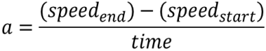](http://www.google.com.au/url?sa=i&rct=j&q=formula+acceleration&source=images&cd=&docid=n1BQvXMu3V1gnM&tbnid=tyy5e7co4fxZgM:&ved=0CAUQjRw&url=http://www.etorgerson.net/WebPages/ScienceUnits/A04_Acceleration.html&ei=ivH1UbrJMIiPkwW0pYD4Bg&psig=AFQjCNGKaO8mY3zS4cauOZdzzpsrQErjaw&ust=1375159034805046)

[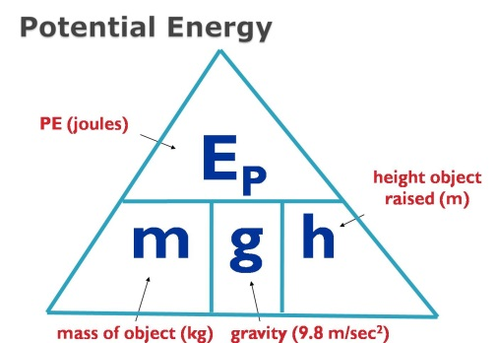](http://www.google.com.au/url?sa=i&rct=j&q=potential+energy+formula&source=images&cd=&cad=rja&docid=2H-GFaF9wBc-AM&tbnid=AD-1C8B0bBkYWM:&ved=0CAUQjRw&url=https://www.allthink.com/v/potentialenergy&ei=hqQRUs2qJsiNkAWSp4DICQ&psig=AFQjCNFHln3I7-BEBHAERUecIisFWqbMGw&ust=1376974319301500)

**Multiple Choice Answer Sheet**

1. A B C D 16. A B C D

2. A B C D 17. A B C D

3. A B C D 18. A B C D

4. A B C D 19. A B C D

5. A B C D 20. A B C D

6. A B C D 21. A B C D

7. A B C D 22. A B C D

8. A B C D 23. A B C D

9. A B C D

10. A B C D

11. A B C D

12. A B C D

13. A B C D

14. A B C D

15. A B C D

**1** What distance would a cockroach, crawling at a speed of 1.5 centimetres per second, cover in an hour?

A 5400 m

B 5.4 m

C 54 m

D 0.54 m

**2** A train travels at a speed of 18 m/s. This is equivalent to a speed of:

A 5 km/h

B 64.8 km/h

C 64 800 km/h

D 0.005 km/h

**3** Inertia can be defined as:

A the amount of matter in an object

B a tendency of an object to resist a change in its motion

C the force of gravity on an object

D when a force makes something move

**4** Mai has a mass of 45 kg. On Planet Zulptor she weighs 351 N. The acceleration due to gravity on Planet Zulptor is:

A less than that on Earth

B the same as that on Earth

C greater than that on Earth

D unable to be determined

**5** A 90 N force is applied to a 65 kg mass. The mass will accelerate at:

A 0.72 m/s2

B 1.2 m/s2

C 1.4 m/s2

D 5.9 m/s2

**6** A skydiver glides to the ground at a steady speed of 7 metres per second. Which statement below best describes what is happening?

A The upward force of air resistance acting on the skydiver is smaller than the downward weight force that is acting

B The upward force of air resistance that is acting on the skydiver is larger than the size of the downwards weight force

C The upward force of air resistance balances the downwards force of gravity acting on the skydiver

D The weight force that acts on the skydiver is larger than the upwards force of air resistance

**7** Which of the following is best explained by Newton’s third law?

A Unbelted passengers will be thrown forward when a car stops suddenly.

B A gun recoils when a shot is fired.

C The acceleration of an object when a force is applied depends on the mass of the object.

D The weight of an object varies from planet to planet.

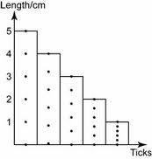

**8** Jack pushed a trolley along a bench and measured its motion using ticker tape. He created the following graph.

Which of the following is true about the motion of Jack’s trolley?

A The trolley maintained a constant speed

B The trolley accelerated

C The trolley decelerated

D The trolley travelled for 5cm

**9** A racehorse runs a race that starts and finishes at the same point. If the race was 1000 metres, what was the displacement of the horse when it finished?

A 1000 metres

B 500 metres

C 10 metres

D 0 metres

**10** The racehorse now runs a second race but is unable to finish due to a sore leg and stops to a halt at a distance of 120 m east of the finish line. Given that the distance to be run in the race was 1000 m, and that the finish line was where the race started, the displacement of the racehorse is now:

A 120 m east

B 120 m west

C 880 m east

D 880 m west

**11** Shown below is a displacement–time graph for Van as he walks to a friend’s house and returns over a day. Which of the following statements concerning this journey is correct?

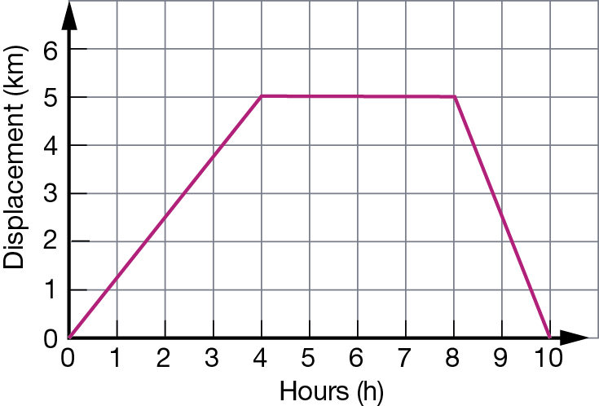

A The total distance travelled for the journey was 5 km.

B The total distance travelled for the journey was 10 km.

C The total displacement for the journey was 5 km.

D A one-hour rest break was made during the journey.

**12** Given that Van’s velocity is the gradient of this graph at any moment, select the correct response from the alternatives below:

A Van walks faster to his friend’s house than on the way home.

B Van’s average velocity on the way to his friend’s house was 1 km/h.

C Van walks faster on the way home than he did when walking to his friend’s house.

D Van’s average velocity on the way home from his friend’s house was 5 km/h.

**13** Three students, Jane, Indira and Charlotte run in a 100 m sprint on a school sports day. The displacement time graph of their motion is shown below.

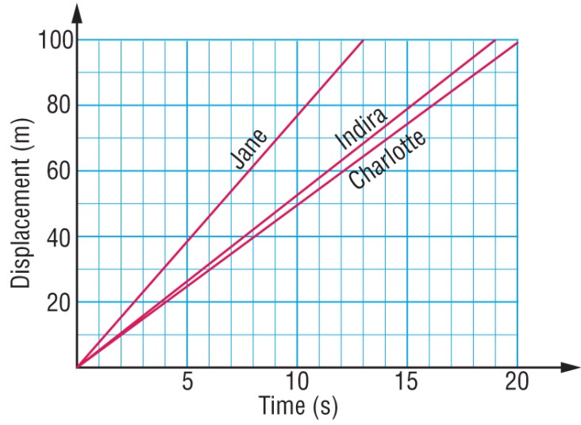

Select the alternative below that correctly orders their finish places in the race.

A Jane wins, Indira is second and Charlotte is third.

B Indira wins, Jane is second and Charlotte is third.

C Charlotte wins, Indira is second and Jane is third.

D Charlotte wins, Jane is second and Indira is third.

**14** The motion of three objects, X, Y and Z, is captured using the three ticker tapes shown below.

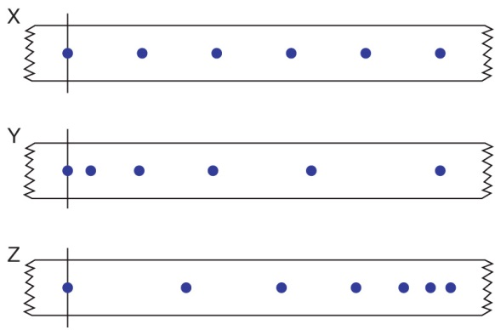

Select the response that best describes the motion of the objects X, Y and Z as described by these sections of ticker tape.

A Object X starts off more slowly than object Y.

B Object X gradually speeds up its motion.

C Object Z starts off with the greatest speed of the three objects.

D Object Y gradually slows its motion.

**15** Refer to the sections of ticker tape shown in the previous question.

Identify the graph from the alternatives shown on the axes below that would best represent the motion of each object as captured on the ticker tape.

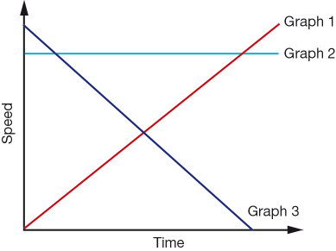

|  |  |  |  |
| --- | --- | --- | --- |
| **Options** | **Motion of Object X is described by graph:** | **Motion of Object Y is described by graph:** | **Motion of Object Z  is described by graph:** |
| A | 3 | 2 | 1 |
| B | 2 | 1 | 3 |
| C | 1 | 2 | 3 |
| D | 1 | 3 | 2 |

**16** Power is the rate at which energy is supplied. What power is needed to supply 6000 J to lift a teenager 10 m up a vertical cliff face in 5 seconds?

A 1200 J/s

B 120 J/s

C 300 000 J/s

D 30 000 J/s

**17** The greater the rebound height of a ball, the greater is the efficiency of energy transfer from gravitational potential to kinetic energy. Five balls are all dropped from a height of 2.0 m. The rebound height of each is listed in the table below:

|  |  |
| --- | --- |
| **Type of ball** | **Rebound height (m)** |
| Basketball | 1.42 |
| Tennis ball | 1.55 |
| Squash ball | 0.05 |
| Cricket ball | 0.68 |

The type of ball that transferred gravitational potential energy to kinetic energy the most efficiently in this test was the:

A Basketball

B Tennis ball

C Squash ball

D Cricket ball

**18** The efficiency of a ball is the ratio of the rebound height and the height dropped. Use the table in the previous question to select the likely efficiency of the four balls tested.

|  |  |  |  |  |
| --- | --- | --- | --- | --- |
|  | 1. **Efficiency of basketball** | 1. **Efficiency of tennis ball** | 1. **Efficiency of squash ball** | 1. **Efficiency of cricket ball** |
| 1. A | 1. 2.5 % | 1. 34% | 1. 78% | 71% |
| 1. B | 1. 78% | 1. 2.5% | 1. 34% | 1. 71% |
| 1. C | 1. 34% | 1. 71% | 1. 78% | 1. 2.5% |
| 1. D | 1. 71 % | 1. 78% | 1. 2.5% | 1. 34% |

**19** In what units is energy measured?

A kilograms

B kilometres

C joules

D metres

**20** Which of the following has kinetic energy?

A A car parked on a hill.

B A boy running.

C A stretched rubber band.

D A helicopter hovering in the same spot.

**21** Which of the following factors affect the amount of kinetic energy possessed by an object?

A Mass and speed.

B Volume and height.

C Temperature and volume.

D Height and speed.

**22** What units is force measured in?

A kilograms

B kilometres

C joules

D Newtons

**23** Terminal velocity is:

A 9.8ms2

B The rate of change of velocity in a falling object

C The final velocity of a falling object when it can fall no faster due to air resistance.

D The speed an object could fall at if there were no air restistance.

**Short Answer Show full working in all calculations**

**1** ` Calculate the average speed (**in m/s**) of (2)

**a** Tay-A, who runs 882 metres in 625 seconds

[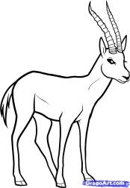](http://www.google.com.au/url?sa=i&rct=j&q=gazelle&source=images&cd=&cad=rja&docid=kwg2iPcbpPv3YM&tbnid=-Bu-rscZri4ugM:&ved=0CAUQjRw&url=http://www.dragoart.com/tuts/10091/1/1/how-to-draw-a-gazelle,-gazelle.htm&ei=qOEaUqjbFsiplQW34oCgCg&psig=AFQjCNGG6PYaOC_O64MCaluItuwxNoedSQ&ust=1377579809200925)**b** A gazelle that runs10 kilometres in 7.5 minutes. (2)

[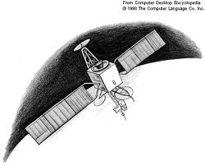](http://www.google.com.au/url?sa=i&rct=j&q=communications+satellite&source=images&cd=&cad=rja&docid=cRqE_rBRz3KLxM&tbnid=h4gxQea4jQnceM:&ved=0CAUQjRw&url=http://encyclopedia2.thefreedictionary.com/Communications+Satellite&ei=guEaUpO7Acn5kgXA-YC4DQ&psig=AFQjCNG_W44ZuKgO8Gj6oLWN1RW1OsiZIA&ust=1377579760128856)

**2** Calculate the distance travelled by:

**a** a communications satellite moving around the Earth at a speed of 3100 m/s for one day (2)

**b** Ford, after walking at a speed of 1 m/s for 45 minutes. (2)

**3** The school bus slows from 60 km/h to 40 km/h when entering the school zone.

**a** Calculate the conversion of these speeds from km/h to m/s. (2)

**b** Given that this change of speed occurred over 8 seconds, calculate the average deceleration of the bus. (2)

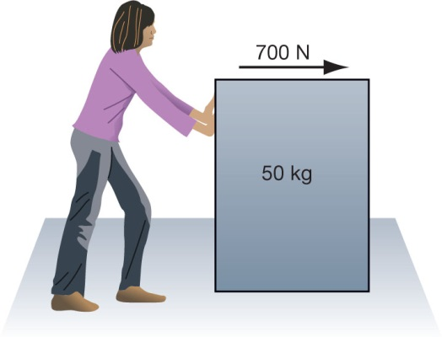

1. **4** Rochelle exerts a force of 700 N on a 50kg crate as shown.
2. The crate accelerates at 9 m/s2.

a Friction acts between the crate and the carpet. **Calculate** the size of the friction force acting on the crate. (2)

b **Demonstrate** where this force acts by marking the force using an arrow on the diagram. (1)

[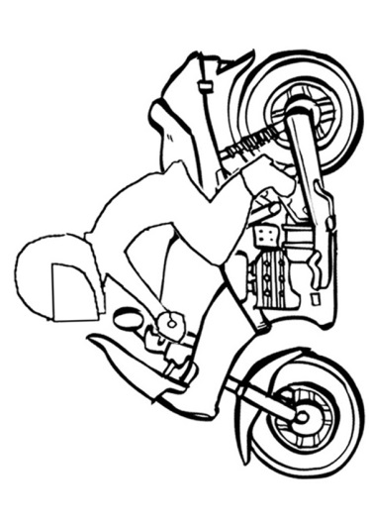](http://www.google.com.au/url?sa=i&rct=j&q=motor%20bike&source=images&cd=&cad=rja&docid=59vIO0SfgXzrAM&tbnid=vZbWn5ZQbUmREM:&ved=0CAUQjRw&url=http://www.kidspot.com.au/slideshow/slideshow/Kids-Activity-SheetsColouring-Pages+2+Motorbike-Colouring-Page+1987+preview.htm&ei=QeEaUrmrIMnGkQWPiYH4Dw&psig=AFQjCNEB_TaE5SHbp1gX3iSZKN6g3cSTnw&ust=1377579704515189)**5** A motorbike starts moving when a traffic light changes green. The table below shows its speed each second.

|  |  |
| --- | --- |
| 1. Time (s) | 1. Speed (m/s) |
| 1. 0 | 1. 0 |
| 1. 1 | 1. 2 |
| 1. 2 | 1. 8 |
| 1. 3 | 1. 13 |
| 1. 4 | 1. 16 |
| 1. 5 | 1. 16 |

Calculate the bike’s:

**a** acceleration during the first 3 s (2)

**b** average acceleration for the whole 5 s. (2)

1. **6** Using the speed–time graph shown below, calculate the:
   1. distance travelled in the first 3 seconds. (2)
   2. total distance travelled (2)
2. .

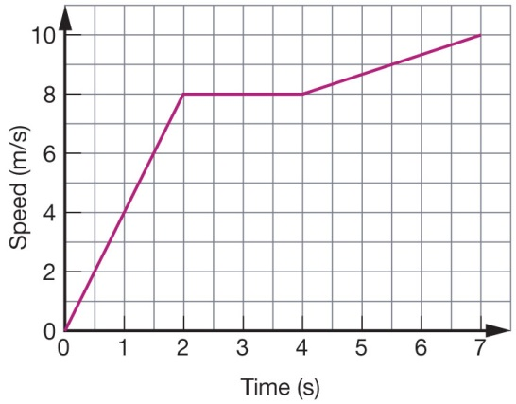

**7** Explain the effect that each of the following changes would have on the acceleration of an object.

**a** The force acting on an object is tripled. (1)

_______________________________________________________________________________________________________________________________________________________________________________________________________________________________________________________________________________________________________________________________________

**b** The mass of an object is halved, while a constant force is applied. (1)

_______________________________________________________________________________________________________________________________________________________________________________________________________________________________________________________________________________________________________________________________________

[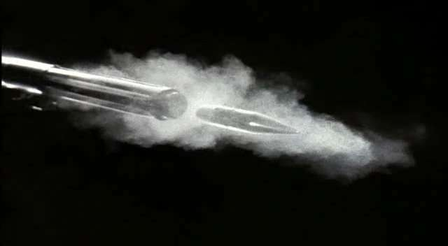](http://www.google.com.au/url?sa=i&rct=j&q=rifle+bullet&source=images&cd=&cad=rja&docid=UUtFTOhkAU_8LM&tbnid=pZLApBQq7IacmM:&ved=0CAUQjRw&url=http://www.spiritofbaraka.com/naqoy247&ei=_uAaUr-ZNcqQkwWgwoGgBg&psig=AFQjCNEY8-4bkQvSzwZzaGz_g2Ide4Tg9Q&ust=1377579630981788)

**8** Calculate the kinetic energy of a bullet of mass 50 g that leaves a rifle with a speed of 900 m/s. (2)

**9** Calculate the work done when:

**a** a force of 25 N moves an object a distance of 8 metres (2)

**b** How much work would be done if Mr Lafferty was unable move the object? (1)

[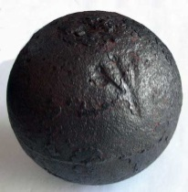](http://www.google.com.au/url?sa=i&rct=j&q=cannon+ball&source=images&cd=&cad=rja&docid=REhdMcxh8vAm6M&tbnid=bsIp3e-fHC61rM:&ved=0CAUQjRw&url=http://angloboerwarmuseum.com/Boer12v_fake_cannonballs.html&ei=z-AaUvaVNoLEkwXLtoH4Cw&psig=AFQjCNHDO8GXvy9Xi5RT-DPkDGvSlBWT4w&ust=1377579595195469)

**10** A cannonball of mass 5 kg is dropped from a height of 12 metres off a cliff.

Calculate:

**a** the potential energy of the cannonball before it was dropped. (Assume gravitational field strength is 9.8 N/kg.) (2)

**b** the speed of the cannonball as it reaches the ground. (Assume that all the potential energy of the object is converted to kinetic energy.).

Hint: You will need to use Ek = ½ ms2  (2)

**SOLUTIONS**

1. A B C D 16. A B C D

2. A B C D 17. A B C D

3. A B C D 18. A B C D

4. A B C D 19. A B C D

5. A B C D 20. A B C D

6. A B C D 21. A B C D

7. A B C D 22. A B C D

8. A B C D 23. A B C D

9. A B C D

10. A B C D

11. A B C D

12. A B C D

13. A B C D

14. A B C D

15. A B C D

**Short Answer Show full working in all calculations**

**1** ` Calculate the average speed (**in m/s**) of (2)

**a** Tay-A, who runs 882 metres in 625 seconds

1 mark for correct working

1 mark for correct answer with correct units

1.41ms

[](http://www.google.com.au/url?sa=i&rct=j&q=gazelle&source=images&cd=&cad=rja&docid=kwg2iPcbpPv3YM&tbnid=-Bu-rscZri4ugM:&ved=0CAUQjRw&url=http://www.dragoart.com/tuts/10091/1/1/how-to-draw-a-gazelle,-gazelle.htm&ei=qOEaUqjbFsiplQW34oCgCg&psig=AFQjCNGG6PYaOC_O64MCaluItuwxNoedSQ&ust=1377579809200925)**b** A gazelle that runs10 kilometres in 7.5 minutes. (2)

1 mark for working

1 mark for correct answer with correct units

22.22ms

[](http://www.google.com.au/url?sa=i&rct=j&q=communications+satellite&source=images&cd=&cad=rja&docid=cRqE_rBRz3KLxM&tbnid=h4gxQea4jQnceM:&ved=0CAUQjRw&url=http://encyclopedia2.thefreedictionary.com/Communications+Satellite&ei=guEaUpO7Acn5kgXA-YC4DQ&psig=AFQjCNG_W44ZuKgO8Gj6oLWN1RW1OsiZIA&ust=1377579760128856)

**2** Calculate the distance travelled by:

**a** a communications satellite moving around the Earth at a speed of 3100 m/s for one day (2)

1 mark for correct working

1 mark for correct units

267840000m or 267840km

**b** Ford, after walking at a speed of 1 m/s for 45 minutes. (2)

1 mark for correct working

1 mark for correct units

2700m

**3** The school bus slows from 60 km/h to 40 km/h when entering the school zone.

**a** Calculate the conversion of these speeds from km/h to m/s. (2)

60/3.6 = 16.6ms

40/3.6 = 11.1ms

**b** Given that this change of speed occurred over 8 seconds, calculate the average deceleration of the bus. (2)

1 mark for working

1 mark for correct answer with correct units

-.068ms2 

1. **4** Rochelle exerts a force of 700 N on a 50kg crate as shown.
2. The crate accelerates at 9 m/s2.

a Friction acts between the crate and the carpet. **Calculate** the size of the friction force acting on the crate. (2)

f=ma

F-50 x 9

F = 450N

Friction = 700 – 450 = 250N

b **Demonstrate** where this force acts by marking the force using an arrow on the diagram. (1)

[](http://www.google.com.au/url?sa=i&rct=j&q=motor%20bike&source=images&cd=&cad=rja&docid=59vIO0SfgXzrAM&tbnid=vZbWn5ZQbUmREM:&ved=0CAUQjRw&url=http://www.kidspot.com.au/slideshow/slideshow/Kids-Activity-SheetsColouring-Pages+2+Motorbike-Colouring-Page+1987+preview.htm&ei=QeEaUrmrIMnGkQWPiYH4Dw&psig=AFQjCNEB_TaE5SHbp1gX3iSZKN6g3cSTnw&ust=1377579704515189)**5** A motorbike starts moving when a traffic light changes green. The table below shows its speed each second.

|  |  |
| --- | --- |
| 1. Time (s) | 1. Speed (m/s) |
| 1. 0 | 1. 0 |
| 1. 1 | 1. 2 |
| 1. 2 | 1. 8 |
| 1. 3 | 1. 13 |
| 1. 4 | 1. 16 |
| 1. 5 | 1. 16 |

Calculate the bike’s:

**a** acceleration during the first 3 s (2)

1 mark for working

1 mark for correct answer with correct units

A=4.3ms2

**b** average acceleration for the whole 5 s. (2)

1 mark for working

1 mark for correct answer with correct units

A = 3.2ms2

1. **6** Using the speed–time graph shown below, calculate the:
   1. distance travelled in the first 3 seconds. (2)

4+8+8

= 20m

* 1. total distance travelled (2)

20+8+8.5+9.5+10

= 56m

1. .



**7** Explain the effect that each of the following changes would have on the acceleration of an object.

**a** The force acting on an object is tripled. (1)

Tripled

**b** The mass of an object is halved, while a constant force is applied. (1)

doubled

**8** Calculate the kinetic energy of a bullet of mass 50 g that leaves a rifle with a speed of 900 m/s. (2)

1 mark for working

1 mark for correct answer with correct units

20250J

**9** Calculate the work done when:

**a** a force of 25 N moves an object a distance of 8 metres (2)

1 mark for working

1 mark for correct answer with correct units

200J

**b** How much work would be done if Mr Lafferty was unable move the object? (1)

none

**10** A cannonball of mass 5 kg is dropped from a height of 12 metres off a cliff.

Calculate:

**a** the potential energy of the cannonball before it was dropped. (Assume gravitational field strength is 9.8 N/kg.) (2)

1 mark for working

1 mark for correct answer with correct units

588J

**b** the speed of the cannonball as it reaches the ground. (Assume that all the potential energy of the object is converted to kinetic energy.).

Hint: You will need to use Ek = ½ ms2  (2)

1 mark for working

1 mark for correct answer with correct units

15.34m/s